EXPERIMENT NO:4
AIM: To design a simple Local Area Network (LAN) and study the working of ARP (Address Resolution Protocol) at the Data Link Layer and ICMP (Internet Control Message Protocol) using the PING utility.
TOOLS/SOFTWARES REQUIRED: Cisco Packet Tracer
THEORY:
Local Area Network (LAN)
A LAN is a group of computers and network devices connected within a limited area such as a classroom, laboratory, office, or building. LAN enables devices to share data and resources like files, printers, and internet connections. Devices in a LAN communicate using Ethernet and are connected using network devices like switches and routers.
ARP (Address Resolution Protocol)
ARP is a protocol used to find the MAC address of a device when its IP address is known.
Since communication on a LAN happens using MAC addresses, ARP helps in mapping an IP address to the corresponding MAC address.
- ARP Request: Broadcast message asking “Who has this IP address?”
- ARP Reply: Response from the device that owns the IP address, sending its MAC address
- ARP Table: Stores IP-to-MAC address mappings
ICMP (Internet Control Message Protocol)
ICMP is used for sending control and error messages in a network. It helps in diagnosing network issues and checking connectivity between devices.
- ICMP Echo Request: Sent by the source device
- ICMP Echo Reply: Sent by the destination device
- ICMP is mainly used by the PING command to check whether another device is reachable

PING Utility
PING is a network command used to test connectivity between two devices in a network. It sends ICMP Echo Request packets and receives ICMP Echo Reply packets.
If replies are received, it means the devices are connected and communication is successful.

PROCEDURE:
- Open Cisco Packet Tracer.
- Drag and place the following devices:
- Two or more PCs
- One Switch
3. Connect all PCs to the switch using Copper Straight-Through cables.4.
4. Assign IP addresses to each PC:
- Go to PC → Desktop → IP Configuration
- Example:
  - PC1: 192.168.1.1
  - PC2: 192.168.1.2
  - Subnet Mask: 255.255.255.0
5. Open Command Prompt on PC1.
6. Use the PING command to check connectivity:
ping 192.168.1.2
7. Observe successful replies showing ICMP communication.
8. To view ARP entries:
arp -a
9. Observe the IP address mapped with MAC address in the ARP table.
10. Repeat the PING and ARP commands from the other PC.
11. Analyze packet flow using Simulation Mode in Cisco Packet Tracer to observe ARP Request, ARP Reply, ICMP Echo Request, and ICMP Echo Reply packets.
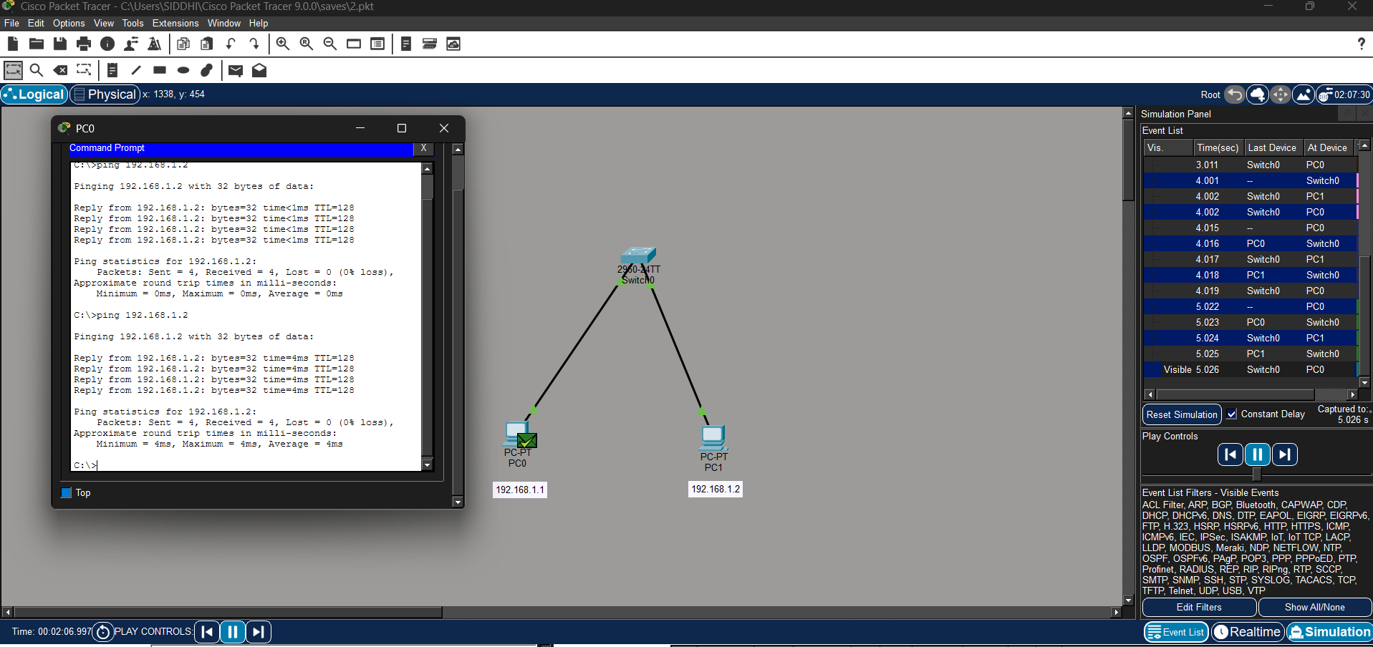
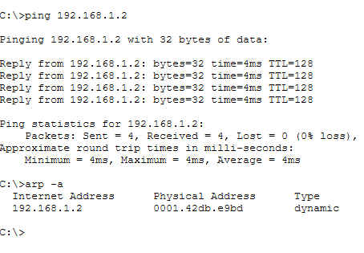
CONCLUSION:
This experiment helped me understand how to configure IP settings on a PC using DHCP and static methods in Cisco Packet Tracer. I learned the role of IP address, subnet mask, gateway, and DNS in network communication. The practical improved my basic networking and configuration skills.

